**WEEK- 2**

**OBJECTIVES**

To help the students in learning about MS-Power Point.

**OUTCOMES**

After completing this, the students would be able to:

❖Understand the usage of MS-Power Point in real life.

**PROBLEMS**

**1# Design Seasonal Greeting cards using MS-Power Point.**

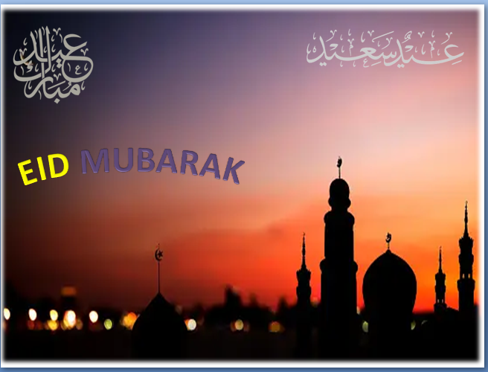

**2# Design an AMU Magazine cover in MS-Power Point. Use the following:**

**[i]Select a theme for the page**

•In Design menu, set "Slide Orientation" to "Portrait" and select theme for the Magazine.

**[ii] Insert either a picture or clipart**

•From Insert menu, select "Picture" or "Clip Art" from Illustrations section.

**[iii] Use WordArt.**

* From Insert menu, select "WordArt" from Text section.

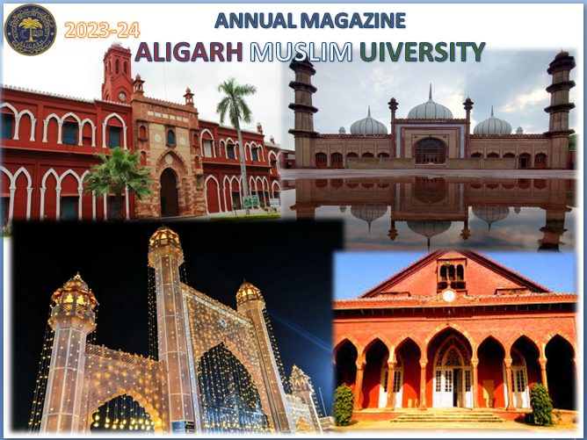

**3# Design a poster inviting all students of your department to the IT Fest.**

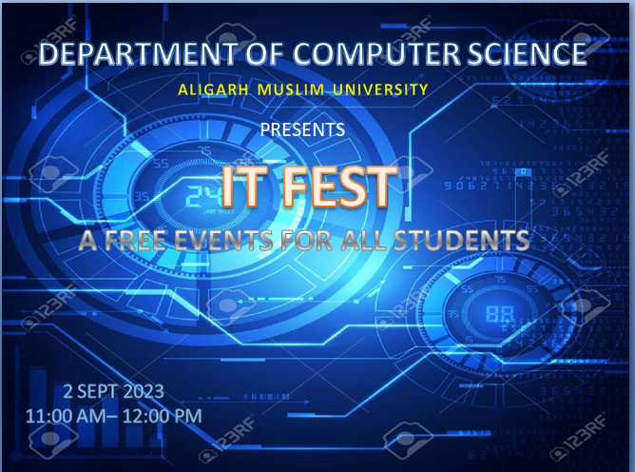

**4# Create a 5-slide presentation on any topic. Use Images, Graphs, Chart, Tables, Animation, Time, Bullets, Transition, Sound, Hyperlink, Background template, Header and Footer.**

**Images**: Insert tab > Pictures option

**Graphs/Charts:** Insert tab > Chart option

**Tables:** Insert tab > Table option > select number of rows and columns **Animation/ Transitions:**

* Click on the "Animations" or "Transitions" tab.
* Select a desired animation or transition effect from the available options.

**Time**: Click on the "Slide Show" tab >> Rehearse timing option. **Bullets:** Home tab > bullet type from Paragraph section.

**Sound:**

* Click on the "Insert" tab.Select "Audio" and insert the desired audio file.
* Adjust settings for when and how the audio plays. **Hyperlink:**
* Highlight the text or object you want to hyperlink.
* Click on the "Insert" tab and select "Hyperlink."
* Choose the destination URL or slide within your presentation. **Background template**: Design tab >> Themes option.

**Header and footer**: Insert tab >> Header and footer option

Slide-1



Slide-2

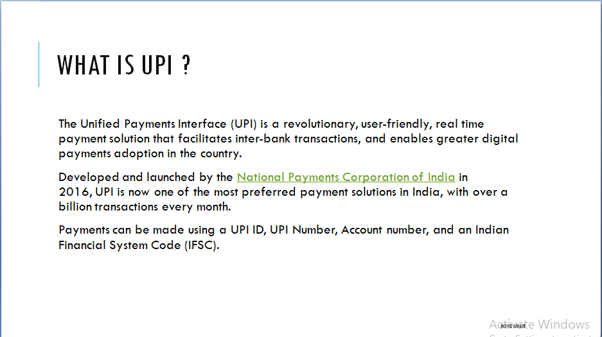

Slide-3

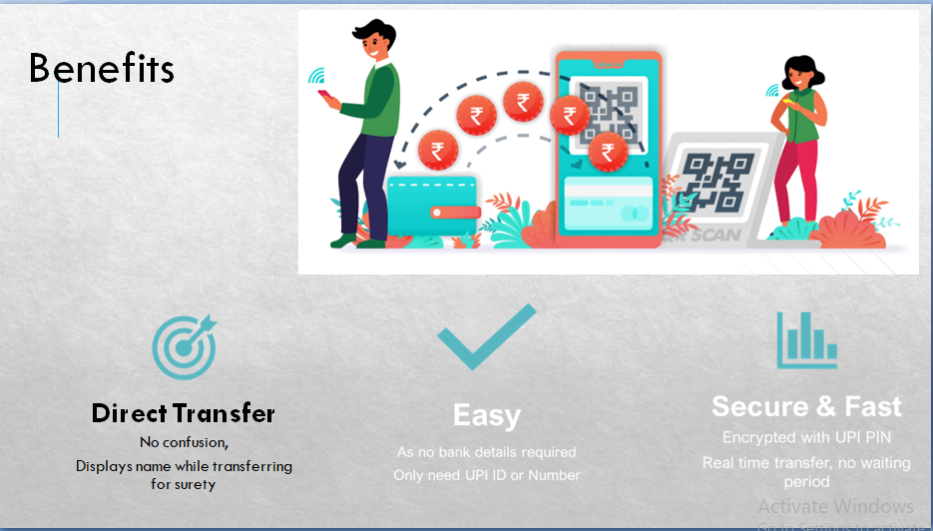

Slide -4

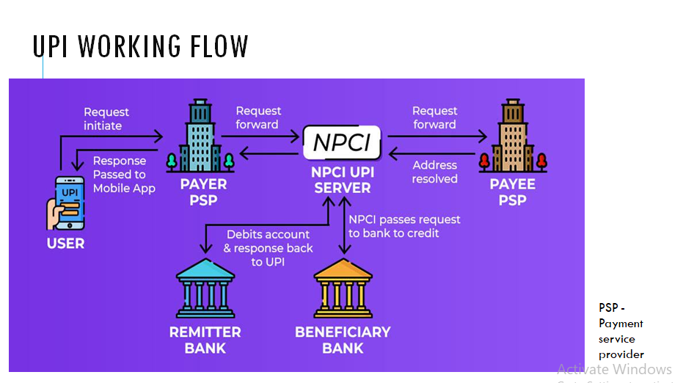

Slide-5

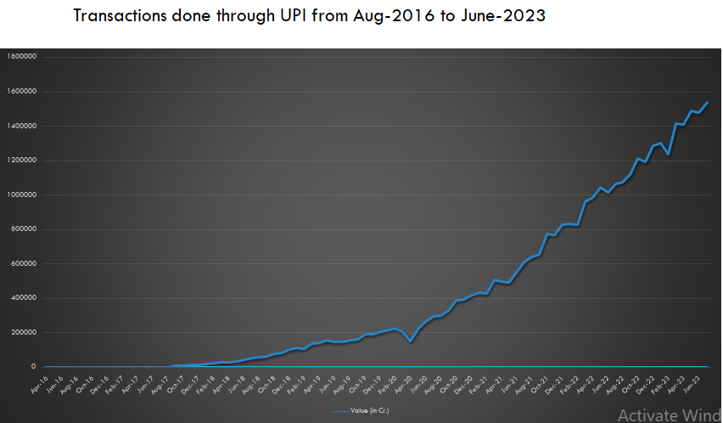

Slide-6

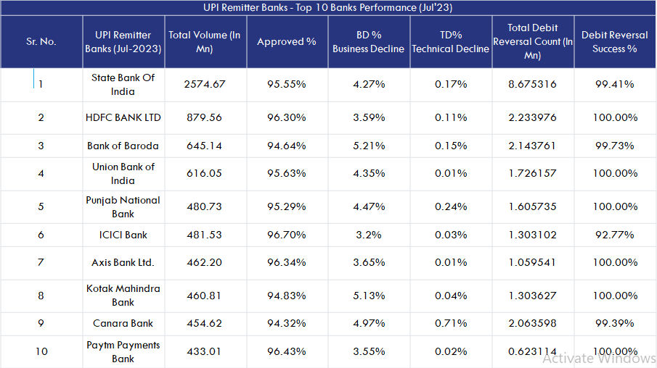

Slide-7

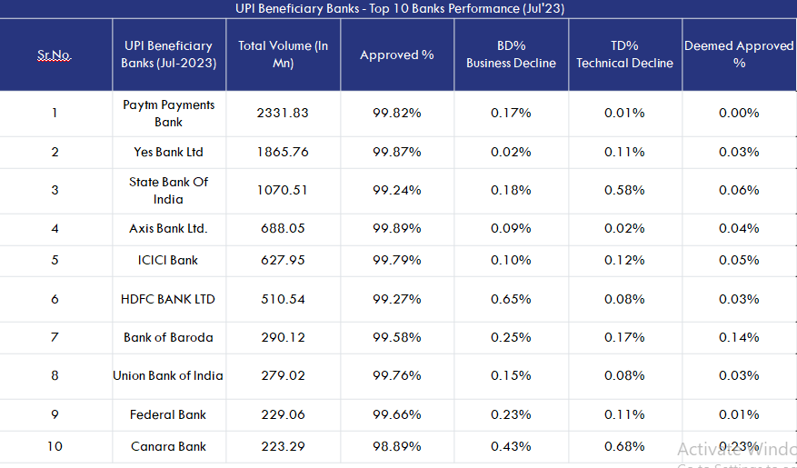

Slide-8

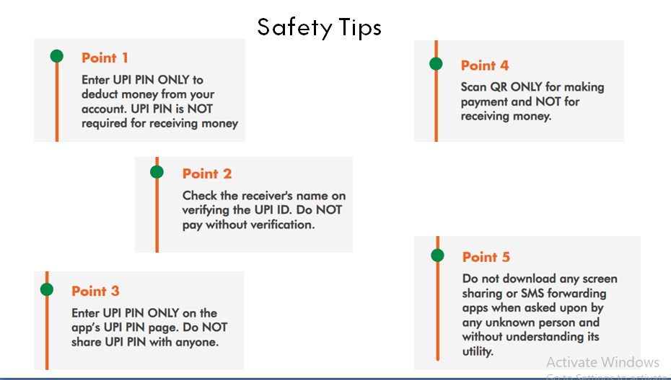

**5# Create a 5-slide presentation on any topic. Use Images, Graphs, Chart, Tables, Animation, Time, Bullets, Transition, Sound, Hyperlink, Background template, Header and Footer.**

